Please, let me pass the

FRCA primary MCQs!!!

So…you have decided to sit the primary MCQs. The question that undoubtedly first passes your lips is where do I start? This is swiftly followed by which books should I buy? Where can I find past questions and which courses should I go on? The list of questions grows rapidly, and your concern about passing what is widely regarded as the most difficult of post graduate exams grows with it.

Our personal experience of the answers to these questions came from a dizzying and all too often confusing array of advice from consultants, trainees, websites, books and bitter experience. What we lacked and subsequently craved was all of this information in one place.

In an attempt to remedy this, we have put together an informal guide to the Primary MCQs. Using the experiences of trainees from Severn Deanery (which frequently has some of the highest success rates in FRCA exams) we will describe the exam format, possible revision techniques, books, question sources and courses that are available to you.

It is important to remember that everyone works differently. Undoubtedly there will be disagreement over some of our suggestions or advice. We do not intend this to be the definitive article on how to pass the primary MCQs, but a guide and a place to start. It is our wish that over the coming years this guide changes and develops as more trainees are successful, discover new books or courses and contribute their ideas and advice. We hope it is of use. Good luck!

Dr Phil Bewley ACCS Anaesthetics CT2b

Dr Catherine Lomasney ACCS Anaesthetics CT2

October 2012

**Updated**

Dr Andrew Grant CT2B,

October 2014

Exam format

A useful guide has been produced by the college which explains the structure of the Primary, and gives plenty of example MCQ and SBA questions. It is called **Guide to the FRCA Examination: The Primary**. The 4th edition is the most up to date and is available here (<http://www.rcoa.ac.uk/sites/default/files/EXM-Primary-Order-Form.pdf>)

The Primary FRCA examination is divided into three sections, a multiple choice question (MCQ) written exam, an objective structured clinical exam (OSCE) and a structured oral examination (SOE). Each section independently has a pass or fail outcome, to achieve an overall pass in the Primary, a candidate must pass all three sections.

The MCQ paper is a stand-alone written examination, applied for independently of the OSCE/SOE, and must be passed before a candidate can apply to sit the OSCE/SOE component. A pass in the Primary MCQ is valid for three years. You are allowed a maximum of five attempts.

The aim of the MCQ paper is to test factual knowledge. The paper consists of 60 True-False (MTF) stems in 3 subsections: Pharmacology, Physiology and Physics.

Each stem has 5 true-false questions, therefore 300 questions in total. There are then 30 Single Best Answer (SBA) questions at the end of the paper, taken from all areas.

Each MTF question is worth 1 mark, whilst each SBA question is worth 4 marks. There are 300 marks for the MTF questions, and 120 marks from the SBAs. There is no negative marking, so never leave a blank box! Don’t forget – SBAs make up a disproportionately high proportion of the total number of marks, so don’t neglect them!

SBA questions differ from MTF in that the stem provides a paragraph of information required to answer the single lead-in question. Five responses are provided from which the candidate chooses the single best response. Only one response is considered ‘best’ and requires careful elimination of the other four options. A key point is that all options should be possible answers and no option should be a statement that is obviously incorrect. The correct score is +4. The score for any other choice is zero.

A true SBA (which has five options that are realistic possible answers) is difficult and time consuming to write. This means the bank of practice questions available to you is smaller than that for MCQs. You should make a conscious effort to find and practice SBAs. It is all too easy to forget about them in the abundance of easily available MCQs. As almost a third of the total available marks come from SBAs, you must not ignore them!

The exam lasts for 3 hours, and you should practice being able to do the 60 MTFs in 2 hours, leaving an hour for the SBAs.

Fees, Dates and Applications

The RCOA website has recently been updated and now has a dedicated examination section (<http://www.rcoa.ac.uk/examinations>). This has an abundance of information that is well organised and easily accessible. Key information from this site is provided below along with relevant hyperlinks (correct at time of publication).

For 2014 the fee to sit the Primary MCQ is £315.

Dates of application and the actual examination can be found on the Royal College calendars (<http://www.rcoa.ac.uk/primary-frca-mcq/dates-fees-and-applications-primary-mcq>).

Application forms are paper based and available at the following site (<http://www.rcoa.ac.uk/examinations/dates-fees-and-applications>). They must be signed by your College Tutor and mailed to the College along with a cheque or postal order for the examination fee made payable to ‘The Royal College of Anaesthetists’. Payment cannot be made by credit cards, debit cards or bank transfers.

Completing the application form is a surprisingly involved process. I cannot emphasise strongly enough that once you have decided to sit the exam, complete the application form, get it signed and mail it early. If you miss the application deadline you will have likely already been revising for a number of months, but be unable to sit the examination. You will receive an e-mail to confirm receipt of your application. If you have not received one within seven days of despatch (or less if the closing date is near) you are advised to contact the Exams Department. Contact details are available here (<http://www.rcoa.ac.uk/examinations/contact-the-exams-department>).

The candidate newsletter is published by the RCOA and is specifically designed to keep FRCA examination candidates informed of updates to exam processes, procedures and regulations. It also has advice on exam timings, statistics and general information on exam sittings. Information is also posted on Twitter. A copy of the most recent addition is sent with your examination confirmation details, but previous copies are available to download at the following site (<http://www.rcoa.ac.uk/examinations/overview/the-candidate-newsletter>). Of real interest is the statistics section which include percentage pass rates for the previous sittings.

Exam Centres

There are several places that you are able to sit the examination, so you don’t have to travel all the way to London. These are: London, Birmingham, Cardiff, Manchester, Sheffield, Edinburgh, Belfast.

When should you sit the Primary MCQs?

This is obviously a personal decision. Traditionally candidates would not sit the exam until they had 12-18 months anaesthetic experience. The clinical experience is useful, helping to make some of the material less abstract, but it also allows you to focus on your supernumerary period (a stressful and tiring time) without having to revise as well. Doing the examination too early could decrease your chances of passing, in fact you cannot apply for the exam until you have been awarded your Initial Assessment of Competencies. However it is worth remembering that to be eligible to even apply for an ST3 anaesthetics post you are required to have passed the entire Primary examination. Try not to view this as a reason to sit the examination early, but as an incentive to plan your sitting appropriately. Remember that from starting CT1 to applying for ST3 is only 18 months or so. Ultimately you have to weigh up the relative pros and cons and chose the time that you think will most enable you to succeed. Some trainees leave a large gap between MCQs and the oral examination and others do them close together so knowledge is still fresh. Your college tutor is up to date and is best placed to advise you on your examination campaign.

Regardless of when you sit the Primary MCQs, it is not an examination to be taken lightly. The pass rate is around 55%. The depth and breadth of knowledge required is daunting and you are frequently covering topics not previously encountered in medical school. It is new material that must be understood first. As such you need to dedicate significant amounts of time to your revision. The exact amount of time required varies and is again a personal choice based on your revision technique, but most individuals I spoke to recommended between three and six months. Ultimately, the examination is as much a test of your commitment to anaesthetics as it is a test of knowledge.

Broad strategy

So you’ve decided to take the plunge, and next to start revising. There are three possible broad revision strategies that you can adopt.

1. **Book work only**

I would personally advise against this as a revision strategy. The curriculum is broad and the questions detailed. Practice questions can be seen as a revision safety net, consolidating what you have learnt, and exposing gaps in your knowledge that you may not have been aware of. However, having a solid knowledge base to start with will help in the long run. The oral examinations require more understanding than just the pattern recognition that you get with only doing questions.

1. **Questions only**

This is a relatively popular strategy. There are an increasing number of online question banks, some with detailed explanations that are making this technique even more convenient. It requires perseverance and realistic expectations; your percentage of correct answers at the beginning will not be sparkling.

1. **Book work and questions**

This was my personal approach to the Primary MCQs. Book work gives a broad understanding of key topics; practice questions will test this and provide additional finer detail. It is also worth remembering that the MCQs are the first part of the Primary, with OSCEs/SOEs and vivas to follow. Book work or notes on key topics that you do now will save time and help in your preparations for these exams.

Practice, Practice, Practice! You can read as much as you like, but eventually you will have to get stuck into practice questions – start these early to get a flavour of the type of questions that will be asked and the depth of knowledge needed.

Organising your revision

Having decided on a broad revision strategy, the next question is ‘what do I need to know?’ A simple enough question, it caused me much stress to begin with. The RCOA is very clear about what it expects you to know for the Primary MCQs. It can be found in the document ‘CCT in Anaesthetics – basic level training’ (available here - <http://www.rcoa.ac.uk/exam-syllabus-and-regulations/examination-syllabus>). Within this large document a useful summary page can be found called – ‘Blueprint of the Primary FRCA examination mapped against basic level units of training.’

It is advisable to use the curriculum to create a road map for your revision, ticking off topics as you complete them. An alternative approach is to simply work through the core text book (discussed later) for each MCQ section (physics/equipment, pharmacology and physiology). This naturally divides your revision into three or four broad topics, and in using these books you invariably cover most of the basic science competencies required of you. You can combine the above two approaches, using a curriculum road map to make sure you aren’t missing any large areas of knowledge. Again, which of the above strategies (if any) you use is a personal choice, but it is often helpful to know what others have done in the past and then adapt this into something that works for you.

We will now take you through the main books, courses and questions banks previous trainees have used.

Books

Unsurprisingly there are a dizzying array of books available to you. We have divided them into the following categories in order that they are more manageable.

* Reference textbooks
* Physics/equipment
* Pharmacology
* Physiology

For the latter three categories, there are certain books that are widely acknowledged as being ‘core’ texts. These are essential reading and form the basis for many Primary MCQs. Such books are highlighted in the passages below.

A common question is which books should you buy? Obviously this is a personal decision, but most would recommend a reference text book, as well as the core texts in pharmacology, physics and physiology. Whilst costing a reasonable amount of money, you will undoubtedly use these books repeatedly throughout your anaesthetic career and in both primary and final FRCA examinations. Wherever possible, try a book before you buy it. Talk to trainees and consultants in your hospital and borrow books for a few days to get a feel for them. Failing that, all the books below are available on Amazon (many in electronic Kindle format - and therefore cheaper), which allows you to look at the first few pages. Many of these books are also available second hand from amazon.

On Line

Obviously there is a dizzying array of information available online. Some of it bad, some of it good, and some of it just wrong.

A good website to begin your revision is [www.frca.co.uk](http://www.frca.co.uk). This has a wealth of knowledge about the exam, and can point you in the right direction for further information. It also has good basic knowledge tutorials to get you started. It also has 1000s of MCQs that it has compiled over the years. Often these are just question and answers though, with no explanation. They are all questions that candidates have previously been asked and contributed to the website.

Another fantastic resource is The Anaesthetic Tutorial of the Week (ATOTW).

<http://www.aagbi.org/education/educational-resources/tutorial-week>

This publishes a new tutorial every week on a different subject. The format is to start with a selection of MQC questions, followed by a short tutorial, and then give the answers at the end. There are 100s of tutorials on-line, with a past library going back years. They are generally very readable and easy to understand. Very useful when you have a spare 10 minutes in theatre.

Reference Textbooks

**1. Fundamentals of Anaesthesia 3rd edition (Cambridge Medicine)**

Tim Smith, Colin Pinnock, Ted Lin

ISBN 9780521692496 RRP - £85

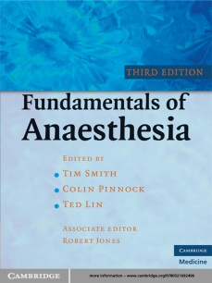**Content**

This follows the Primary FRCA curriculum, and has subsections on clinical anaesthesia, physiology, pharmacology and physics, clinical measurement and statistics.

**Presentation**

Clear and concise. It is well laid out with good colour illustrations, tables and summary boxes.

**Negatives**

This text really does cover most things, but in doing so the explanations for some of the more complex basic sciences can sometimes be brief and therefore difficult to understand.

**Overall**

An excellent general textbook that maps to the Primary FRCA syllabus. Well presented, it is an excellent place to start your Primary revision.

1. **Textbook of Anaesthesia (Churchill Livingstone) 6e.**

Alan R Aitkenhead, Graham Smith, David J Rowbotham

ISBN 0443100853 RRP - £74

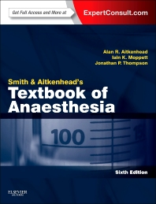

**Content**

Unlike Fundamentals, this is not tailored to the Primary FRCA curriculum and is a more traditional reference textbook

**Presentation**

Plenty of diagrams and tables, but the current edition has no colour.

**Negatives**

Not mapped to the Primary FRCA curriculum and lacks any colour illustrations

1. **Training in Anaesthesia the Essential Curriculum (Oxford Specialty Training)**

Catherine Spoors, Kevin Kiff

ISBN 0199227268 RRP - £60

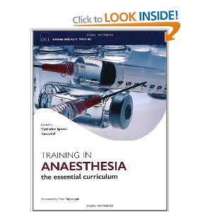**Content**

A more recent text, this too is mapped to the Primary FRCA curriculum, but is organised differently to Fundamentals. Chapters are systems based and broken down into modular two page spreads that incorporate essential pharmacology, physiology and physics topics as appropriate. Core knowledge is broken into bite-size chunks, and as such it can be seen almost as half revision text, half reference text.

**Presentation**

Each sub-section is presented as a two page spread with good use of colour, illustrations and tables.

**Negatives**

Customer reviews report a number of small typing errors.

**Overall**

A text that appears to balance between reference and revision text well. A good place to start your Primary revision.

**4. Anaesthesia and Intensive Care A to Z (Churchill Livingstone)**

Steven Yentis, Nicholas Hirsch, Gary Smith

ISBN 0443067856 RRP - £78

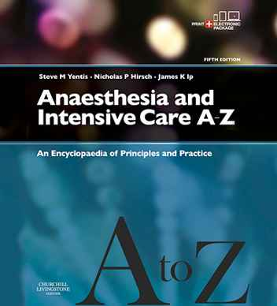

**Content**

An encyclopaedia of anaesthesia and intensive care medicine, all topics are organised alphabetically. Provides easily accessible, concise information on just about any topic you can imagine. Particularly useful when used in conjunction with another reference text to aid understanding of difficult subjects.

**Presentation**

Clear and concise, with good use of tables and diagrams. Not full colour

**Negatives**

Can’t really think of any

**Overall**

A very useful text containing an incredible amount of well organised, concise information and diagrams

Physics and Equipment

1. **Basic Physics & Measurement in Anaesthesia 5e (Elsevier)** - **Core Text**

Paul D Davis, Gavin N C Kenny

ISBN 0750648287 RRP - £55

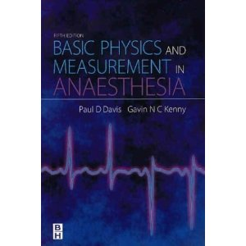

This is the core text books for physics in the Primary FRCA.

You can structure your physics revision entirely on the chapters within this book.

The text can be a little dry, but there are plenty of diagrams to aid your understanding

1. **Essentials of anaesthetic equipment 4th edition (Churchill Livingstone)**

Baha Al-Shaikh, Simon Stacey

ISBN 044310087X RRP - £45

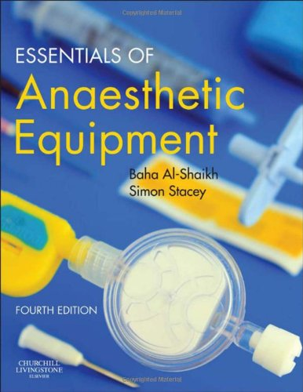**Content**

Well written with excellent colour illustrations and photos that support the text. Works well when used in conjunction with Basic Physics and Measurement in Anaesthesia, and there is overlap between the two texts. Also has summary MCQs with explanations at the end of each chapter.

**Presentation**

Excellent, with good use of illustrations and photos

**Negatives**

None

**Overall**

An excellent supplement to Basic Physics and Measurement in Anaesthesia

1. **Physics, Pharmacology and Physiology for Anaesthetists - Key Concepts for the FRCA 2e (Cambridge Medicine)**

Matthew Cross, Emma Plunkett

ISBN 0521700422 RRP - £35

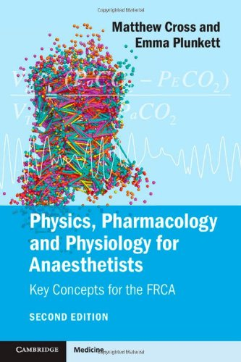

**Content**

I cannot recommend this book highly enough. It covers all major topics in physics, pharmacology and physiology in a concise and simple fashion.

It is THE book to head to for definitions, diagrams and a straightforward description of key principles. It also contains summary tables for all the core pharmacological drug classes.

**Presentation**

No colour, but clear, concise text with excellent diagrams

**Negatives**

Helpful to use it alongside other core books for more details.

**Overall**

An incredibly useful book to supplement your core texts. If you had to buy one extra book, this would be it.

Pharmacology

1. **Pharmacology for Anaesthesia and Intensive Care 4e ( Cambridge Medicine) - Core Text**

T E Peck, S A Hill and M Williams

ISBN 0521704634 RRP - £45

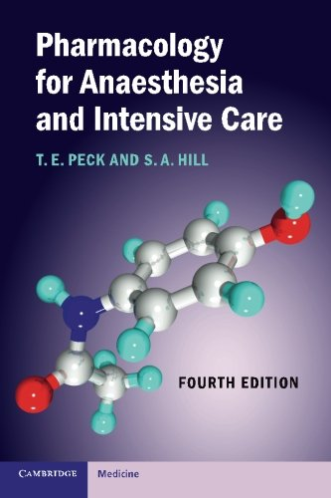

This is the core text for pharmacology within the primary FRCA and covers basic principles (including pharmacokinetics and pharmacodynamics) as well as all the core drugs used in anaesthesia and intensive care. Sue Hill is an examiner at the RCOA, so read this book!

Generally it is an easily accessible text with good summary tables and illustrations to aid understanding.

1. **Drugs in Anaesthesia and Intensive Care (Oxford University Press)**

Susan Smith, Edward Scarth, Martin Sasada

ISBN 0199599386 RRP - £30

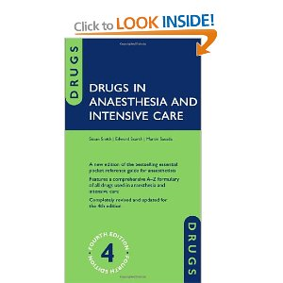**Content**

A comprehensive A - Z formulary of all drugs used in anaesthesia and intensive care.

All drugs are described using the same subheadings (uses, chemical, presentation, main action etc.) which suits some revision styles and is of particular relevance when looking ahead to OSCE VIVAs.

**Presentation**

Concise bullet point style. Allows quick access to information.

**Negatives**

Does not cover basics principles.

**Overall**

Concise, easily accessible information presented in a consistent fashion. Useful both for the Primary and day-to-day clinical experience.

Physiology

There is no clear core general physiology text book that I am aware of, and many of the general reference texts previously discussed now include physiology chapters (in particular Fundamentals of Anaesthesia).

However it is widely acknowledged that Respiratory Physiology by West is an essential revision item. Should you require a dedicated physiology textbook a further two suggestions are made although there are many available.

1. **Respiratory Physiology - The Essentials (Lippincott Williams & Wilkins) - Core Text**

John B West

ISBN 1609136403

RRP - £25

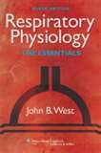

This is the only core physiology text that I am aware of.

Well organised, it contains concise but detailed information with multiple diagrams as well as helpful summary bullet points and MCQs.

The recent ninth edition has additional online animations to aid understanding of the more complex points.

1. **Ganong’s Review of Medical Physiology - 25th Edition (Lange Basic Science)**

Kim E Barrett, Susan M Barman, Scott Boitano, Hedwenn L Brooks

ISBN 0071780033 RRP - £46

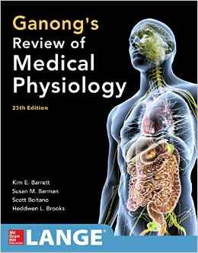

1. **Principles of Physiology for the Anaesthetist**

Peter Kam, Ian Power

ISBN 0340887990

RRP - £48

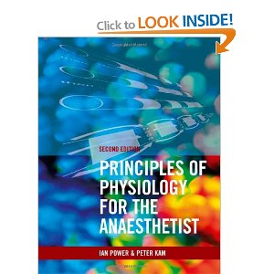

Practice questions

Practice questions are essential to your success in the primary MCQs and they are available from a variety of sources in a variety of formats. Whilst traditionally books of practice MCQs where used, increasingly question banks are becoming available online (some for free).

We describe some of the more commonly used question banks below. Once again this does not pretend to be a complete list of all available questions, merely the ones we have encountered.

**Books**

1. **Guide to the FRCA Examination - The Primary 2013**

RRP - £25

Forms for purchase available here - (<http://www.rcoa.ac.uk/resources-candidates/the-primary-candidate-resources>)

*This book is essential.*

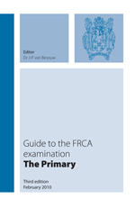It describes the examination format and gives you 90 practice MCQs with answers and explanations.

The MCQs given are drawn from the College question bank, and illustrate the range and content of questions that you will face. Furthermore, some of the questions invariably appear in the examination itself.

It is definitely worth completing these questions a number of times throughout your revision.

The fourth edition is the latest. Speak to your consultants and senior trainees to see if they have earlier editions with different practice questions.

1. **Single Best Answer MCQs in Anaesthesia Basic Sciences and Clinical Anaesthesia.**

Pitchiah, Arumugam, 2011. RRP £38.40 each.

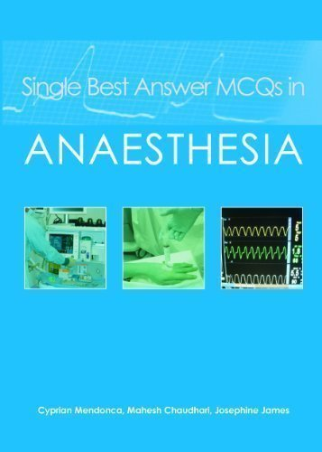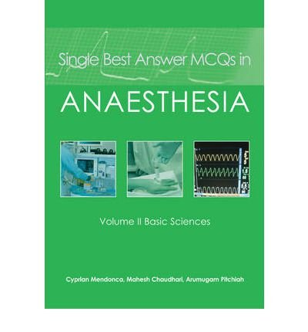**Content:** One of the few books around for the SBA questions.

Well written with 180 SBAs compiled into 6 mock exams. Comprehensive and useful answer explanations.

*A must read for the SBAs.*

2 separate books, Volume 1 is clinical anaesthesia, and Volume 2 is Basic Sciences.

Incidentally this book is given free if you do the Coventry MCQ course.

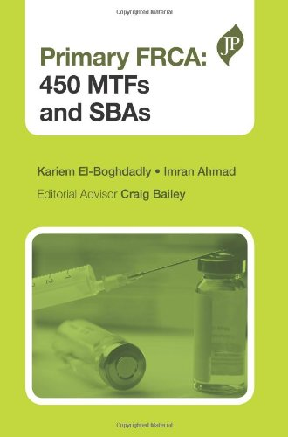

1. **Primary FRCA: 450 MTFs and SBAs.**

[Kariem El-Boghdadly](http://www.amazon.co.uk/Kariem-El-Boghdadly/e/B00NGGOZ7E/ref=dp_byline_cont_book_1), Imran Ahmad, Craig Bailey. 2013. RRP £20

300 MCQ and 150 SBA questions. Broken down in 5 mock exams, followed by comprehensive answers. More up to date than several books out there. Lots of tables and diagrams.

1. **MCQs for the Primary FRCA (Saunders self assessment)**

Craig Bailey, Franco Moscuzza, Adrian Pearce

ISBN 0702021601 RRP - £39

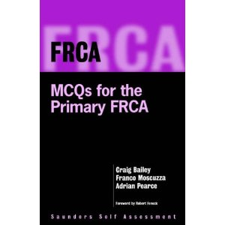

**Content**

Contains 4 practice papers with a good variety of topics covered.

Answers are printed as you progress through the papers (and not at the end) with good concise explanations.

Was published in 1998 so does not include SBAs.

1. **SBA and MTF MCQs for the Primary FRCA (Cambridge Medicine)**

James Nickells, Benjamin Walton and the FRCAQ.com Writers Group

ISBN 1107604060 RRP - £18.50

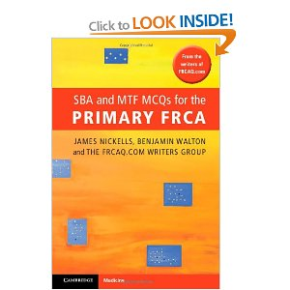

**Content**

A recent publication featuring questions found on the FRCAQ website, this book contains 120 MCQs as well as 60 SBAs that cover many of the key topics on the syllabus.

Answers are given at the end of the question papers along with a short explanation and a more in depth long explanation to further aid your revision.

All questions have been written by Severn deanery consultants and anaesthetic trainees.

1. **Q-Base Anaesthesia**

A number of Q Base volumes exist in both paper and CD formats.

Volumes four, five and six are available to purchase on Amazon. Older volumes can be purchased used. Ask around your department, more senior trainees often have the CDs buried away somewhere and are more than happy to surrender them.

The questions themselves cover a good range of topics (beware older volumes not being as relevant) but provide only very brief explanations.

Online Questions

1. The Rcoa website.

The RCOA have published 2 sets of SBAs so far. They are obviously the most representative examples of questions that may come up, although there are no explanations. Often questions here are found in the actual exam.

They can be found here:

<http://www.rcoa.ac.uk/system/files/EXM-SBA-QUESTIONS.pdf>

<http://www.rcoa.ac.uk/sites/default/files/EXM-Example-PrimarySBAs.pdf>

1. **Elearning for anaesthesia**

<http://www.e-lfh.org.uk/projects/ela/index.html>

Free website from e-lfh (but invaluable!). Has over 750 tutorials covering the first 2 years of anaesthetic training. This is an incredibly in depth and useful resource. It would take you years to work through all of it, so pick and choose which modules to do. Each module ends with a selection of MCQs and SBAs. There are also a few large question banks and mock exams within the website. They also release a selection of questions 2 weeks before the exam. This website is written by RCOA tutors and so follows the curriculum exactly. Many questions from here appear in the actual exam.

**3. FRCA Q**

<http://www.frcaq.com/primary/jsp/home.jsf>

Cost - 1 month £20, 2 months £35, 4 months £60

A new site dedicated entirely to the Primary FRCA MCQs. It is led by two Severn Deanery consultants with questions written by existing trainees.

Contains a total of over 1500 MTFs and SBAs with four different testing options available to you.

Importantly the questions have been designed to cover every single aspect of the Primary FRCA curriculum. Answers are presented as both a short explanation and if required a more detailed, fully referenced long explanation to aid your revision further.

**4. Pastest**

<http://www.pastest.co.uk/product/frca-online?rbc=true&rcid=105663>

Cost £55 or £89

Contains 720 MTFs and 356 SBAs

**5. Onexamination**

[http://www.onexamination.com/anaesthesia/frca-primary](http://www.onexamination.com/anaesthesia/frca-primary%20)

1 month - £31. 4 months - £62.

990 MQC and 350 SBA questions.

**6. Dr Podcast**

<http://www.dr-podcast.co.uk/index.php>

£76.50

Particularly useful for those trainees with a commute looking to maximise their revision time. FRCA primary podcasts cover the whole FRCA syllabus and have been written by a successful candidate and reviewed by an experienced consultant.

They are particularly useful for OSCE/vivas, but are also valuable in understanding broad concepts for the MCQs. The podcasts are now also available in print format and include diagrams to aid understanding. This is available below

<http://www.amazon.co.uk/gp/product/1107401003>

Courses

There are a number of courses available to aid your revision. Popular courses book up fast, so apply for your study leave and book early. Almost universally courses are held a few weeks prior to the examination. As such they are not there to teach you content, but test what you know, fill in small gaps in your knowledge and fine-tune your exam technique. Some of the better known courses are listed below.

1. **Pensinsula Primary MCQ Course**

<http://www.sdhct.nhs.uk/postgradtraining/peninsulaprimarymcqcourse/>

Cost - £300 including lunch and refreshments.

Duration – 3 days

Venue - Buckfast Abbey, Devon

Constitutes practice MCQs and tutorials on core topics. Rated by previous trainees as being a good comprehensive course. Tutorials are given by knowledgeable senior trainees or consultants. Plenty of techniques for MCQs, including an insight into how questions are answered by other candidates. Good value for money and a nice setting for the course.

1. **Coventry MCQ Course**

<http://www.mededcoventry.com/Courses/Anaesthesia/FRCA/Default.aspx>

Cost - £260 including breakfast and refreshments

Venue - University Hospital, Coventry

Duration - Three days

A three day course of intensive MCQ/SBA practice.

Practice papers are completed and then answers discussed using presentations from senior trainees and consultants. Culminates in a mock three hour test paper with feedback on performance.

Covers over 350 MCQs and 180 SBAs. SBAs are answered in group format using interactive technology.

Cost includes an online pre-course MCQ club that provides 20 past questions a week for six weeks prior to the course start date.

1. **Royal College Master Class**

[http://www.rcoa.ac.uk/education-and-events/primary-frca-masterclass-0](http://www.rcoa.ac.uk/education-and-events/primary-frca-masterclass-0%20)

Venue - The Royal College of Anaesthetists, London

Cost - £305

College run primary course, provides practice questions taken form the college bank. Each tutorial is preceeded by a mock exam, which is electronically marked and returned at the end of the tutorial. Tutorials are designed to cover areas that candidates generally do poorly in. The instructors have included authors of the core textbooks and are very knowledgeable.

1. **Mersey Primary MCQ course**

http://www.msoa.org.uk/courses/

Cost - £450 including breakfast, lunch, car parking and refreshments

Duration – 7 days

An intensive week long course. It is important to understand that this course has no didactic input from senior trainees or consultants.

The course fee gives you access to past papers constructed by the organiser using previous attendees. These papers are said to be highly reflective of previous exams. You then work through the papers as part of a small group. Importantly you are not given the correct answers or explanations to these papers, but arrive at the answers in conjunction with the other members of your group.

This is obviously not a learning style that will suit everyone, but it does provide you with unparalleled access to past questions.

Phew, the end!

This guide is there to provide some helpful hints and is the personal opinion of the authors only. If anyone disagrees with some aspects or wants to add further information they are very welcome to email the authors. It is the aim that the guide will be fluid, and amended by future trainees as the examination or available resources change.

**Finally - good luck to everyone sitting the exam!**